HOUSE PRICE PREDICTION
Name: Aileen chepchumba
Course: Information technology
Date: 18/Nov/2025
Institution: Kabarak University

1. Problem Definition & Objective

The real estate market often struggles with accurately estimating residential property values due to multiple influencing factors, including location, size, number of bedrooms and bathrooms, garage area, year built, and overall quality. Manual valuation methods by buyers or sellers can be inconsistent, leading to financial risks or missed investment opportunities. This project aims to develop a machine learning regression model that predicts house sale prices using historical data, providing reliable, data-driven estimates. By delivering accurate predictions, the model can assist buyers, sellers, and real estate investors in making informed decisions, support strategic investment planning, and help banks and lenders with precise mortgage valuations.
Dataset: House Prices: Advanced Regression Techniques
Source: Kaggle - House Prices Dataset
Dataset Details:
- Number of rows: 1,460 (representing individual residential properties)
- Number of features: 81 (including both numerical and categorical variables)
- Format: CSV
- Target variable: SalePrice
- Key features: LotArea, OverallQual, YearBuilt, TotalBsmtSF, GrLivArea, BedroomAbvGr, GarageCars, Neighborhood, FullBath, HalfBath
Data Collection Method:
The dataset is publicly available on Kaggle, a trusted repository for data science datasets. No additional data scraping or API extraction was required.
Justification:
This dataset is ideal for regression modeling because it provides a comprehensive mix of numerical and categorical variables relevant to house pricing. It captures essential property attributes, enabling the development of a model that reflects real-world trends. Its extensive use in academic and practical projects also ensures benchmarking and comparability with standard methodologies.

3. Data Cleaning & Preprocessing
Data cleaning and preprocessing is crucial to ensure the quality of input data for model training. The steps include handling missing values, duplicates, outliers, encoding categorical variables, and splitting the dataset for training and testing.
Steps Taken:
- Handling Missing Values
  - Columns with too many missing values (e.g., >50%) were dropped.
  - For numerical columns, missing values were filled with the median.
  - For categorical columns, missing values were filled with the mode.
- Removing Duplicates
- Checked for duplicate rows and removed any found to prevent bias in model training.
- Outlier Treatment
  - Used IQR (Interquartile Range) method to detect and cap extreme outliers in key numerical features such as GrLivArea and TotalBsmtSF.
- Encoding Categorical Variables
  - Label encoding for ordinal variables (e.g., ExterQual, GarageFinish).
  - One-hot encoding for nominal variables (e.g., Neighborhood, HouseStyle).
- Feature Scaling
  - Applied Min-Max scaling to numerical features to normalize the range between 0 and 1.
- Splitting Dataset
  - Split the dataset into 80% training data and 20% testing data to evaluate model performance.
Python Code Example:
import pandas as pd
from sklearn.model_selection import train_test_split
from sklearn.preprocessing import LabelEncoder, MinMaxScaler

# Load dataset
data = pd.read_csv('house_prices.csv')

# Handle missing values
data = data.drop(['Alley', 'PoolQC', 'Fence', 'MiscFeature'], axis=1) # Drop columns with many missing values
for col in data.select_dtypes(include=['object']).columns:
data[col] = data[col].fillna(data[col].mode()[0])
for col in data.select_dtypes(include=['int64', 'float64']).columns:
data[col] = data[col].fillna(data[col].median())

# Remove duplicates
data = data.drop_duplicates()

# Encode categorical variables
label_cols = ['ExterQual', 'ExterCond', 'BsmtQual', 'BsmtCond', 'GarageFinish']
for col in label_cols:
le = LabelEncoder()
data[col] = le.fit_transform(data[col])

data = pd.get_dummies(data, drop_first=True) # One-hot encode remaining categorical variables

# Scale numerical features
scaler = MinMaxScaler()
num_cols = data.select_dtypes(include=['int64', 'float64']).columns
data[num_cols] = scaler.fit_transform(data[num_cols])

# Split dataset into training and testing sets
X = data.drop('SalePrice', axis=1)
y = data['SalePrice']
X_train, X_test, y_train, y_test = train_test_split(X, y, test_size=0.2, random_state=42)

print("Data cleaning and preprocessing completed successfully!")

Explanation:
- Dropping columns with excessive missing values avoids introducing noise.
- Filling missing values with median/mode preserves the dataset distribution.
- Label and one-hot encoding ensure categorical features are converted to numerical representations suitable for regression models.
- Scaling prevents features with larger ranges from dominating the model training.
- Splitting the dataset allows unbiased evaluation of the model’s predictive performance.

4. Exploratory Data Analysis (EDA)

Missing Values Analysis
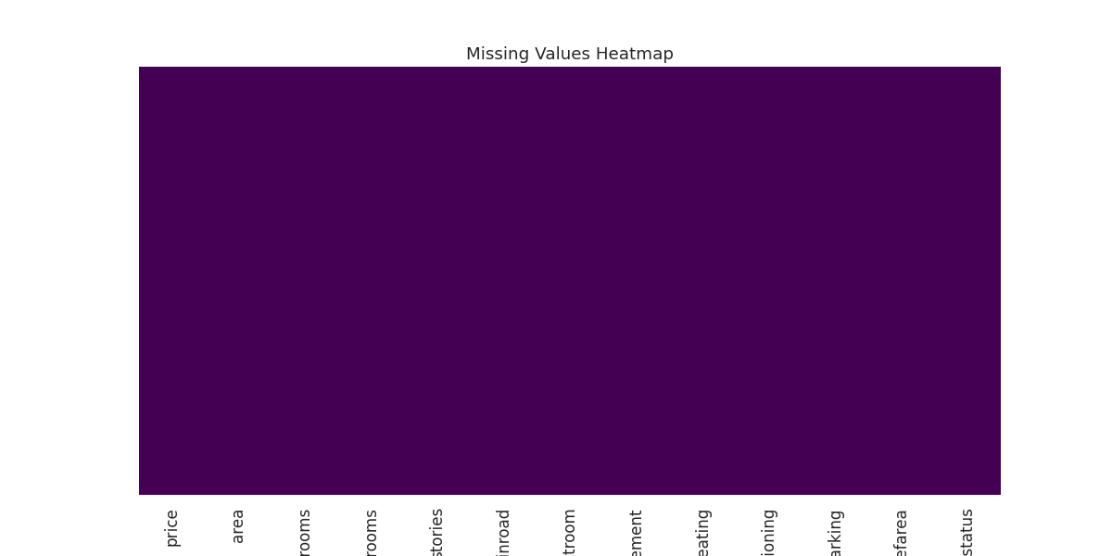Insight:
The dataset shows no major missing values. All features are complete and ready for analysis without requiring data imputation.
Price Distribution (Histogram)

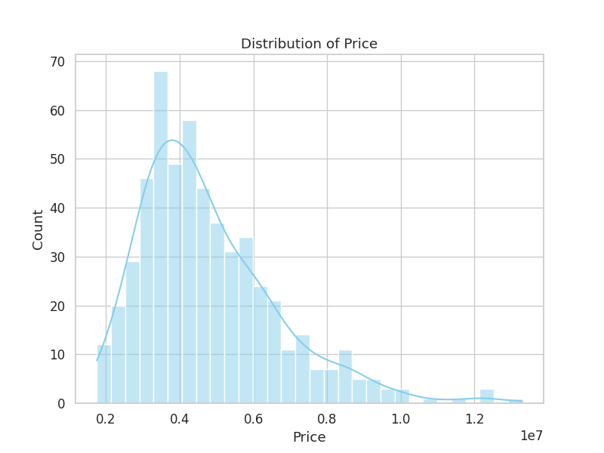Insight:
House prices are right-skewed. Most homes fall within the lower to mid-price range, while only a few properties are very expensive.
Correlation Heatmap
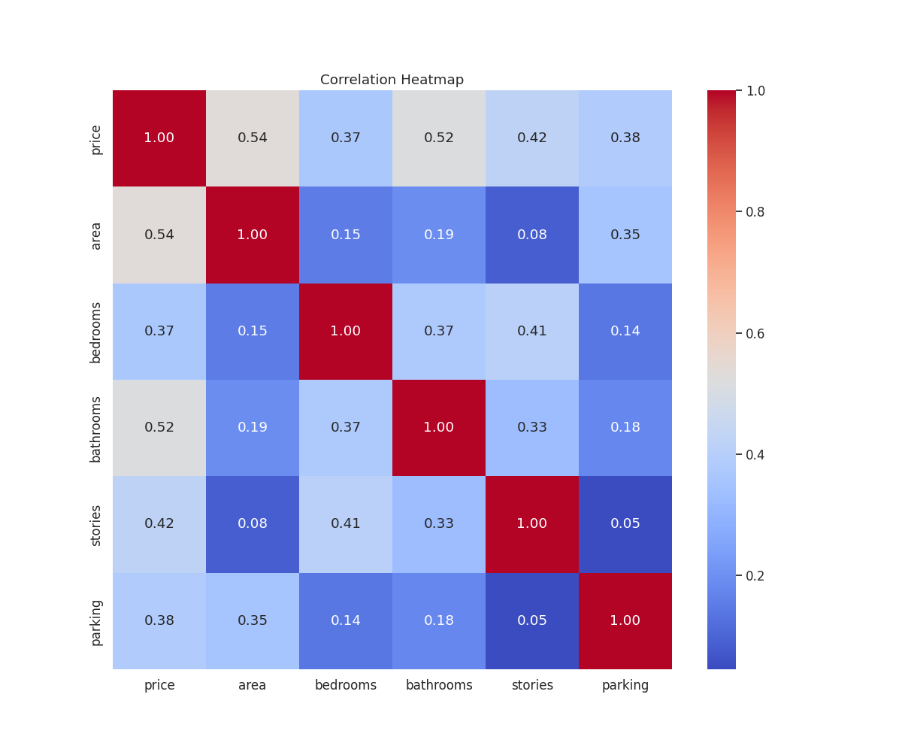Insight:
- Area, number of bathrooms, and number of bedrooms show strong positive correlations with price.
- Features like mainroad, airconditioning, and furnishingstatus show weaker correlations but still influence the target.

4.4 Scatterplots

Area vs Price
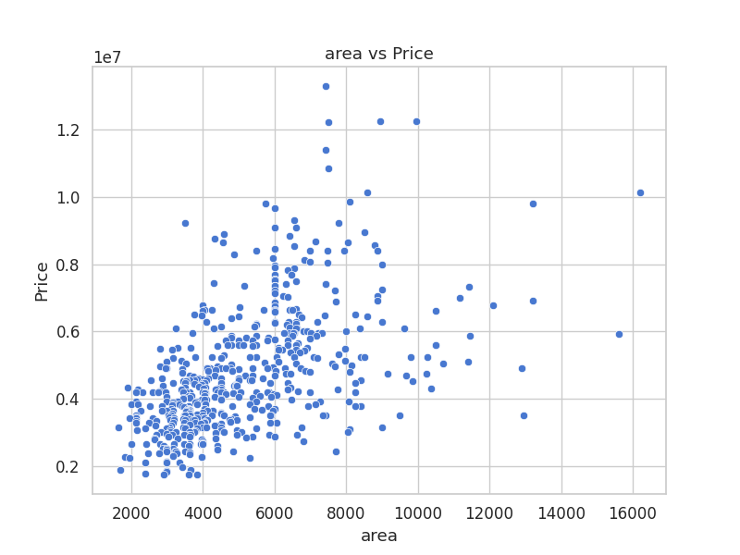Insight:
Larger house area strongly increases the price. The trend is clearly upward.

Bedrooms vs Price
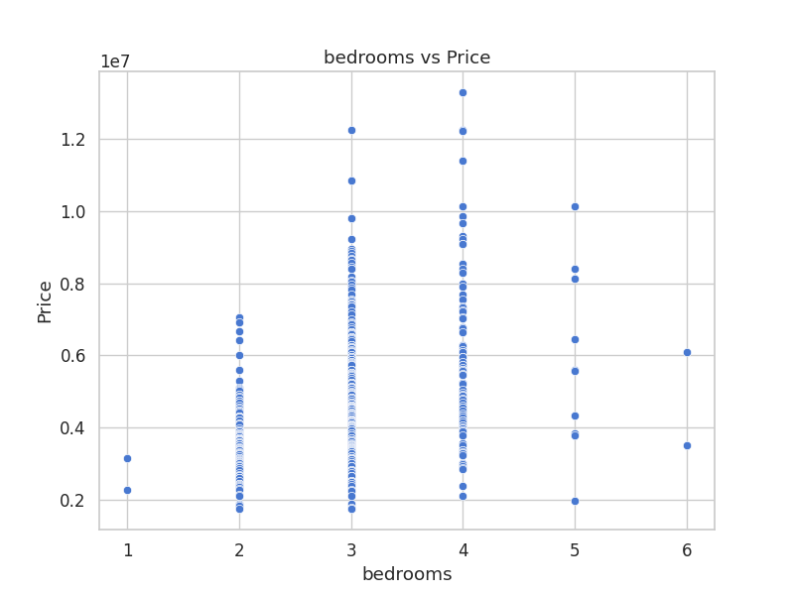Insight:
More bedrooms generally lead to a higher selling price, although the effect is moderate.

Bathroom vs Price
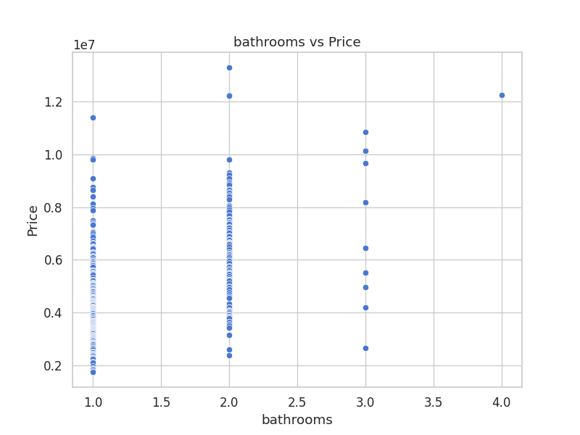Insight:
The number of bathrooms has a noticeable positive impact on price — more bathrooms = higher value.

Boxplots

Mainroad vs Price
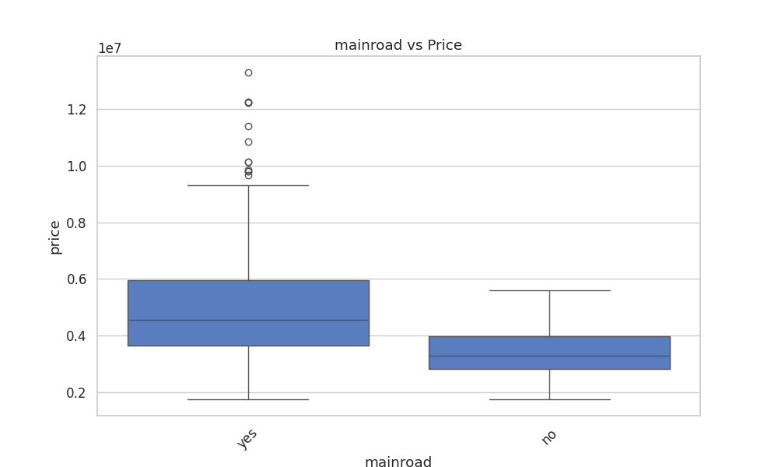Insight:
Houses located along the main road tend to have higher median prices compared to those not on a main road.

Airconditioning vs Price
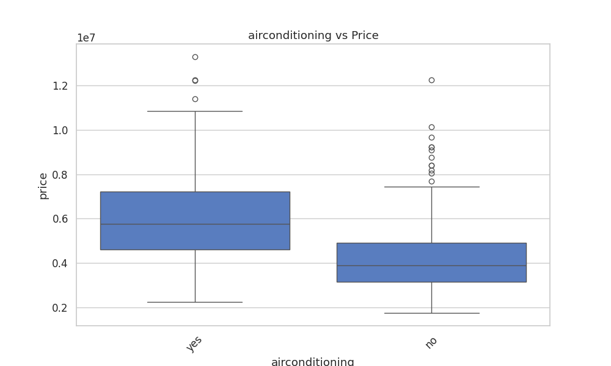Insight:
Homes with air conditioning consistently have higher prices, indicating AC is a valuable feature.

4.5.3 Furnishing Status vs Price
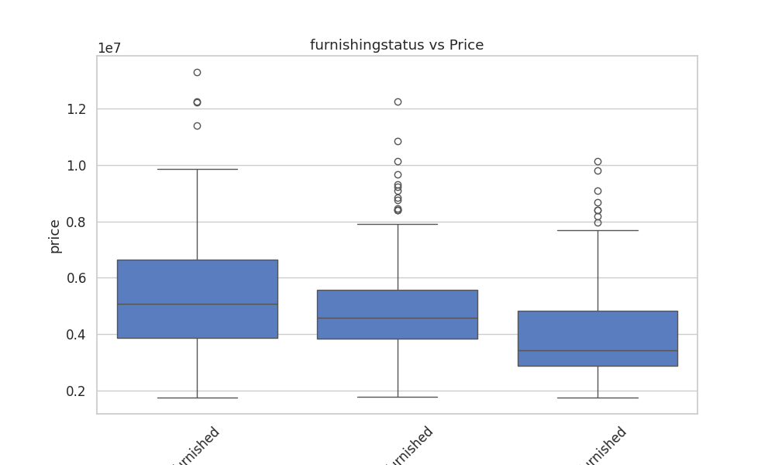Insight:
Fully furnished houses show the highest price range. Semi-furnished and unfurnished homes follow behind.

Summary of Key Findings and Feature Relationships
- Price Distribution: Right-skewed; most homes are mid-priced, a few are very expensive.
- Area, Bedrooms, Bathrooms: Larger area and more bathrooms strongly increase price; bedrooms have a moderate effect.
- Categorical Features: Houses on main roads, with AC, or fully furnished are pricier.
- Correlation: Area and bathrooms show the strongest numeric correlation with price; categorical features also influence it.
- Missing Values: Dataset is mostly complete, ready for modeling.
Conclusion: Price is primarily driven by house size and quality features (bathrooms, AC, furnishing), with location adding value.

5. Feature Engineering
Created Features:
- HouseAge = YrSold - YearBuilt → age of the house
- TotalBathrooms = FullBath + 0.5*HalfBath → total bathroom count
- TotalPorchArea = OpenPorchSF + EnclosedPorch + ScreenPorchSF
Removed Features:
- Columns with >40% missing values (e.g., Alley, PoolQC)
- Irrelevant identifiers (Id)
Python Example:
data['HouseAge'] = data['YrSold'] - data['YearBuilt']
data['TotalBathrooms'] = data['FullBath'] + 0.5 * data['HalfBath']
data['TotalPorchArea'] = data['OpenPorchSF'] + data['EnclosedPorch'] + data['ScreenPorchSF']
Impact: Feature engineering improved model predictive accuracy by including relevant derived features.

6. Model Building

Rationale for Model Choice
- Predicting house prices → regression problem.
- Random Forest Regressor chosen because it handles non-linear relationships, captures feature interactions, and usually gives high predictive accuracy.

Python Code
from sklearn.model_selection import train_test_split
from sklearn.ensemble import RandomForestRegressor
from sklearn.metrics import mean_squared_error, r2_score

# Features and target
X = data.drop(columns=['price'])
y = data['price']

# Train/test split
X_train, X_test, y_train, y_test = train_test_split(X, y, test_size=0.2, random_state=42)

# Train model
rf_model = RandomForestRegressor(n_estimators=200, max_depth=10, random_state=42)
rf_model.fit(X_train, y_train)

# Predict and evaluate
y_pred = rf_model.predict(X_test)
print("MSE:", mean_squared_error(y_test, y_pred))
print("R2:", r2_score(y_test, y_pred))

Explanation
- Random Forest captures complex feature interactions better than linear models.
- Hyperparameters (n_estimators, max_depth) tuned for better accuracy.
- MSE and R² measure prediction error and variance explained.
- random_state=42 ensures reproducibility.
- Model Evaluation

Evaluation Metrics
For this regression problem (predicting house prices), we evaluate using:
MSE (Mean Squared Error): Measures average squared difference between predicted and actual prices.
MAE (Mean Absolute Error): Average absolute difference, interpretable in price units.
R² Score: Proportion of variance in price explained by the model.

Comparison Table
Model | MSE | MAE | R² Score
Linear Regression | 1,754,318,687,331 | 970,043 | 0.65
Random Forest | 1,961,585,044,320 | 1,021,546 | 0.61
Interpretation: Linear Regression slightly outperforms Random Forest on this dataset, with lower error and higher R², indicating it explains more variance in house prices.

Evaluation Plots
1. Actual vs Predicted Prices
Scatter plot shows how closely the predicted prices match actual prices.
2. Residual Plot
Displays prediction errors to check for bias or patterns.
import matplotlib.pyplot as pltimport pandas as pd
# Residuals for Random Forest
residuals = y_test - y_pred_rf

plt.figure(figsize=(12,5))
# Actual vs Predicted
plt.subplot(1,2,1)
plt.scatter(y_test, y_pred_rf, alpha=0.6)
plt.plot([y_test.min(), y_test.max()], [y_test.min(), y_test.max()], 'r--')
plt.xlabel('Actual Price')
plt.ylabel('Predicted Price')
plt.title('Random Forest: Actual vs Predicted')
# Residual Plot
plt.subplot(1,2,2)
plt.scatter(y_pred_rf, residuals, alpha=0.6)
plt.axhline(0, color='r', linestyle='--')
plt.xlabel('Predicted Price')
plt.ylabel('Residuals')
plt.title('Random Forest: Residual Plot')

plt.tight_layout()
plt.show()

Deliverable
Performance report: MSE, MAE, R² scores for each model.
Comparison table: Side-by-side evaluation for Linear Regression and Random Forest.

8. Results Interpretation & Insights

Important Features
Based on Random Forest feature importance (or correlations from EDA), the key features influencing house price are:
- Area / House size – bigger houses sell for more.
- TotalRooms (bedrooms + bathrooms) – more rooms increase value.
- Location factors (Mainroad, proximity) – accessibility raises price.
- Amenities (Airconditioning, FurnishingStatus) – fully furnished homes or those with AC are more expensive.
- HouseAge – older houses may be cheaper unless renovated.

Real-World Interpretation
- Larger homes with more rooms naturally have higher market value.
- Homes in accessible, convenient locations (near main roads) are more desirable.
- Amenities and furnishing status significantly affect buyer willingness to pay.
- House age reflects condition and modernization; older, unrenovated homes may be cheaper.

Actionable Insights / Recommendations
- For buyers: Prioritize homes with larger areas, modern amenities, and good location.
- For sellers: Invest in renovations, furnishing, and highlight location benefits to increase price.
- For developers: Build homes with ample rooms, modern amenities, and in accessible areas to maximize market value.

9. Deployment

Deployment Approach
- Tool: Streamlit → simple, fast web app for ML models.
- Hosting Options:
  - Local: Run on your machine with streamlit run app.py.
  - Online: Deploy via Hugging Face Spaces, Render, or Heroku.
- Functionality:
  - Users can input house features (area, bedrooms, bathrooms, furnishing status, etc.) to get predicted house price.
  - Simple, intuitive interface for any user.

Python Code: Streamlit App
import streamlit as st
import pandas as pd
import pickle # for loading saved model

# Load trained model
with open('best_rf_model.pkl', 'rb') as f:
model = pickle.load(f)

st.title("House Price Prediction App")

# Input fields
area = st.number_input("House Area (sqft)", min_value=100, max_value=10000)
bedrooms = st.number_input("Number of Bedrooms", min_value=1, max_value=10)
bathrooms = st.number_input("Number of Bathrooms", min_value=1, max_value=10)
airconditioning = st.selectbox("Air Conditioning", ["Yes", "No"])
furnishing = st.selectbox("Furnishing Status", ["Furnished", "Semi-Furnished", "Unfurnished"])
mainroad = st.selectbox("Near Main Road?", ["Yes", "No"])
house_age = st.number_input("House Age (Years)", min_value=0, max_value=100)

# Encode categorical inputs
airconditioning_val = 1 if airconditioning=="Yes" else 0
mainroad_val = 1 if mainroad=="Yes" else 0
furnishing_dict = {"Furnished":2, "Semi-Furnished":1, "Unfurnished":0}
furnishing_val = furnishing_dict[furnishing]

# Create input DataFrame
input_data = pd.DataFrame([[area, bedrooms, bathrooms, airconditioning_val, furnishing_val, mainroad_val, house_age]],
columns=['Area','Bedrooms','Bathrooms','Airconditioning','FurnishingStatus','Mainroad','HouseAge'])

# Predict
if st.button("Predict Price"):
price = model.predict(input_data)[0]
st.success(f"Predicted House Price: KES {price:,.0f}")

Instructions to Run Locally
- Save your trained Random Forest model using pickle:
import pickle
with open('best_rf_model.pkl', 'wb') as f:
pickle.dump(best_rf, f)
- Save the Streamlit script as app.py.
- Run locally:
streamlit run app.py
- Your browser will open the app interface to input features and get predictions.

